**Big Data – Case Study**

**Student Name: Nabh Sanjay Mehta Student Id: NSM190002**

**Date: 04/09/2020**

Part-1: Setup: In this section we will set up the files and data that is required to progress throughout this case study.

Step-1: Open the terminal application on the Cloudera VM desktop.

Q. Take a screenshot of the terminal application and paste it below.

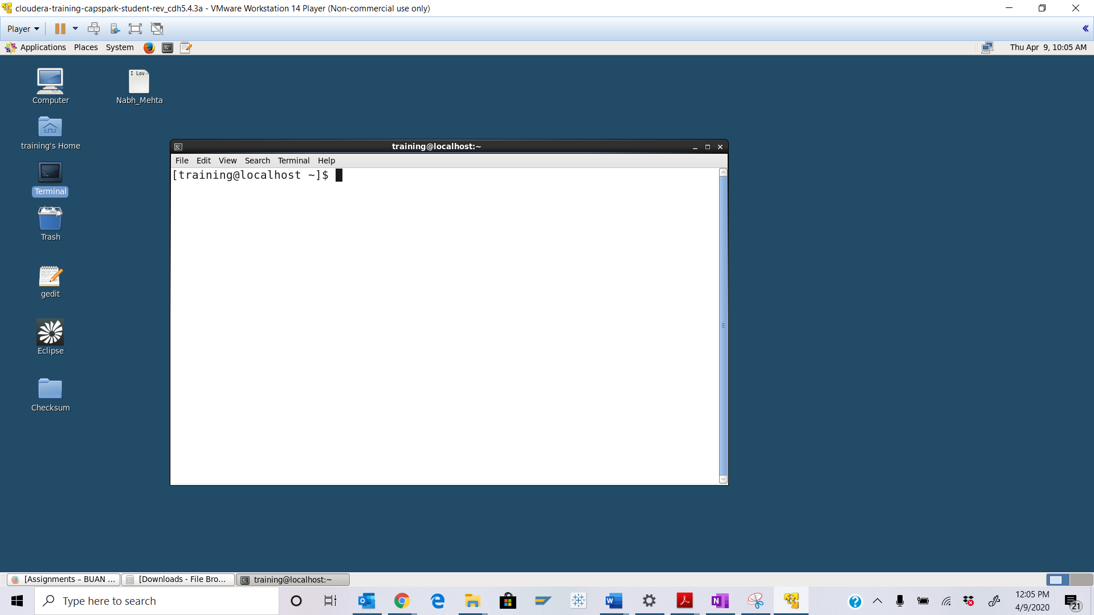

Step-2: Download the Ass_14.zip file from eLearning in to the downloads folder **IN** the Cloudera VM using Mozilla Firefox.

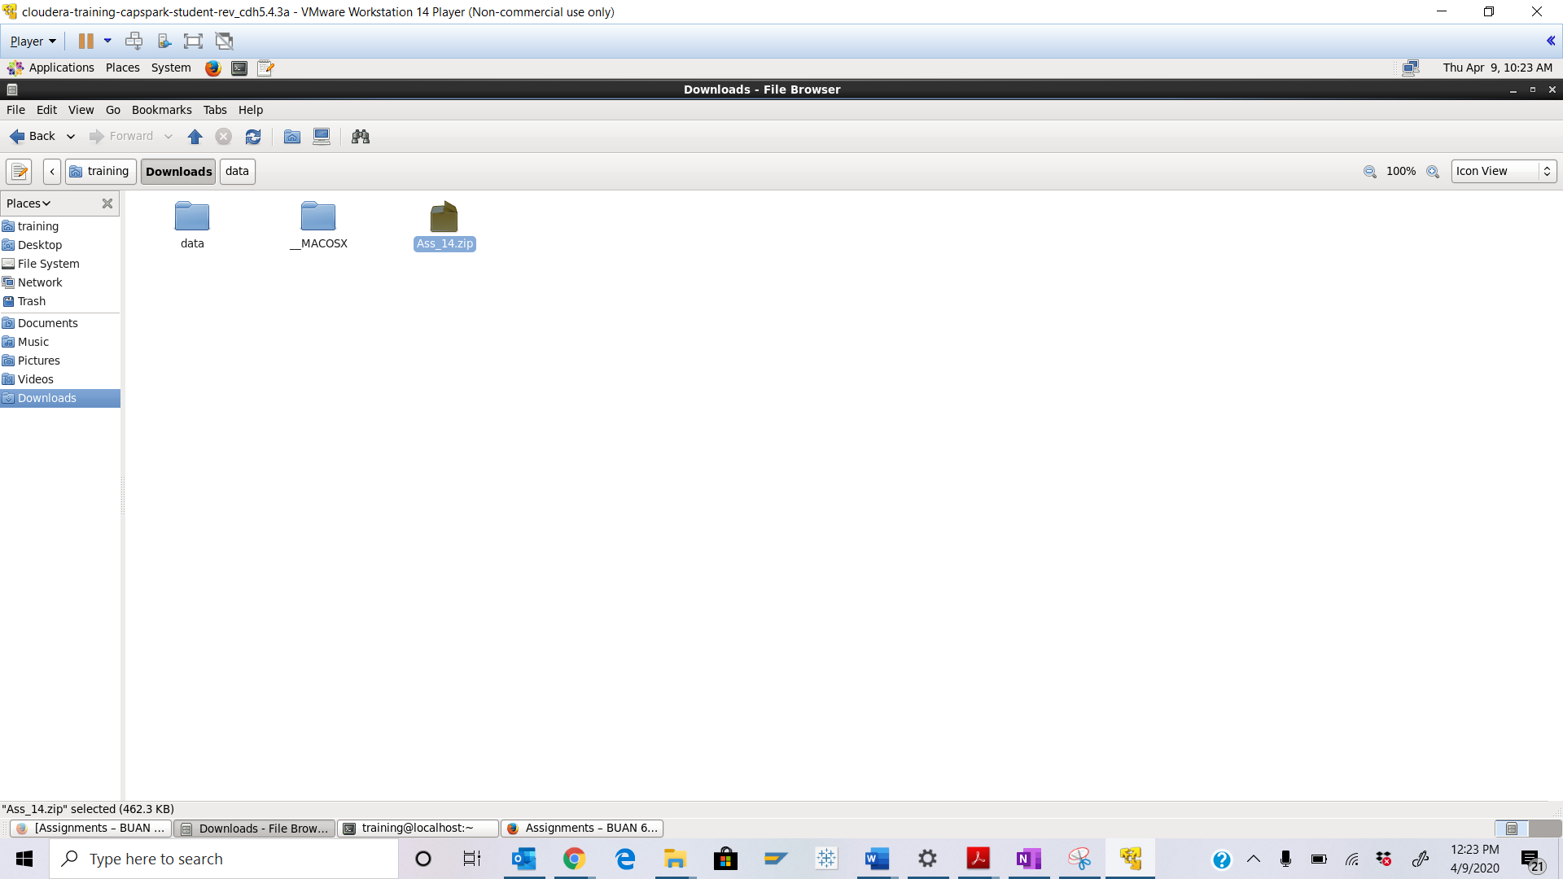

Step-3: Execute the following command:



Q. Now type the command and execute. Take a screenshot of the shell output, highlight the zip file and paste it below.

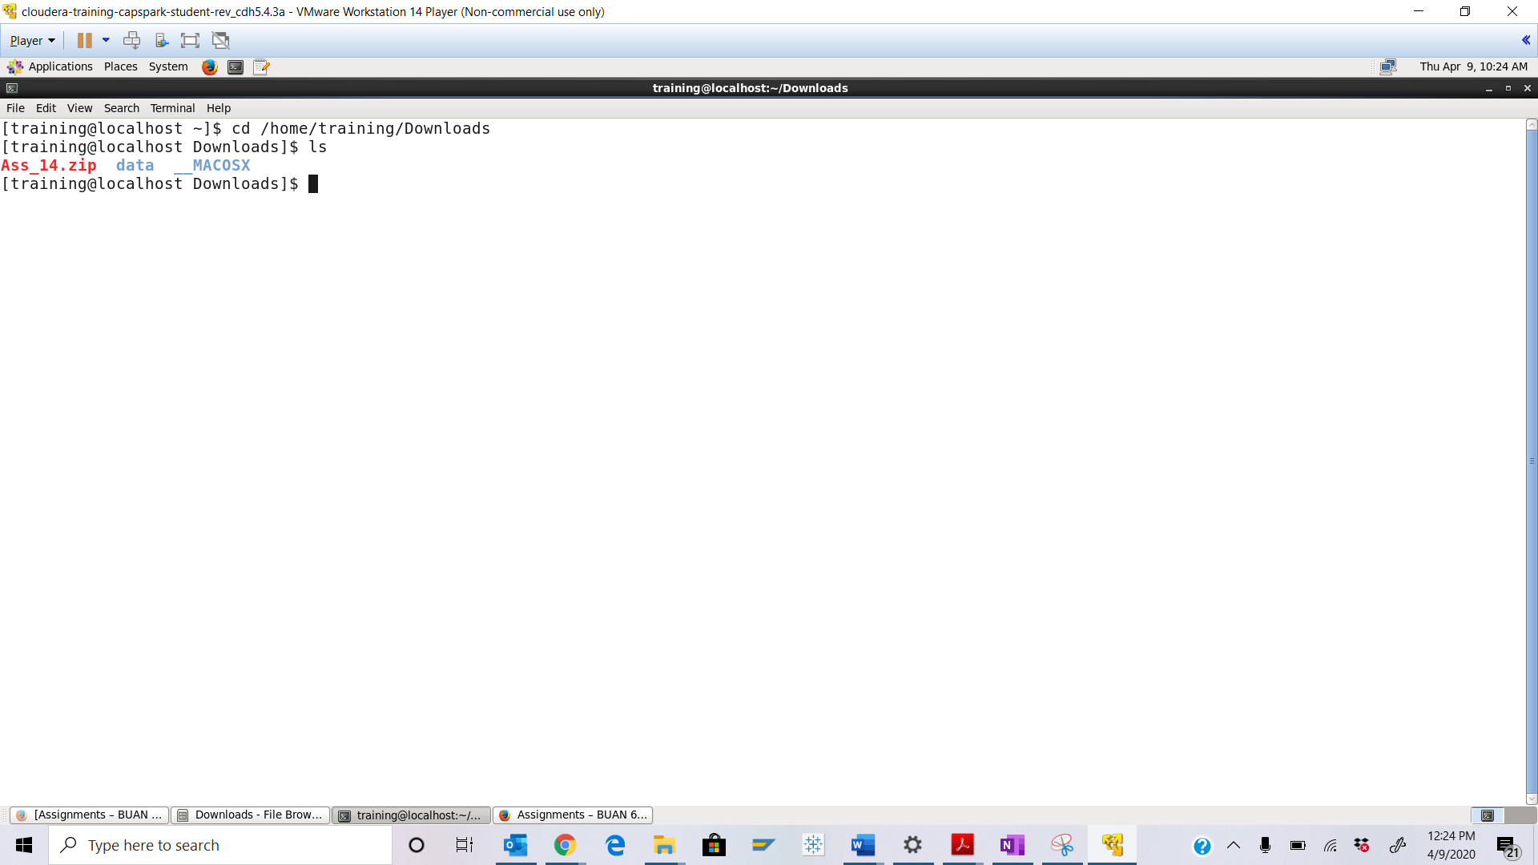



Step-4: Execute the following commands at the shell prompt:





Q. Now type the command and execute. Take a screenshot of the shell output, highlight the contents of the zip file and paste it below.

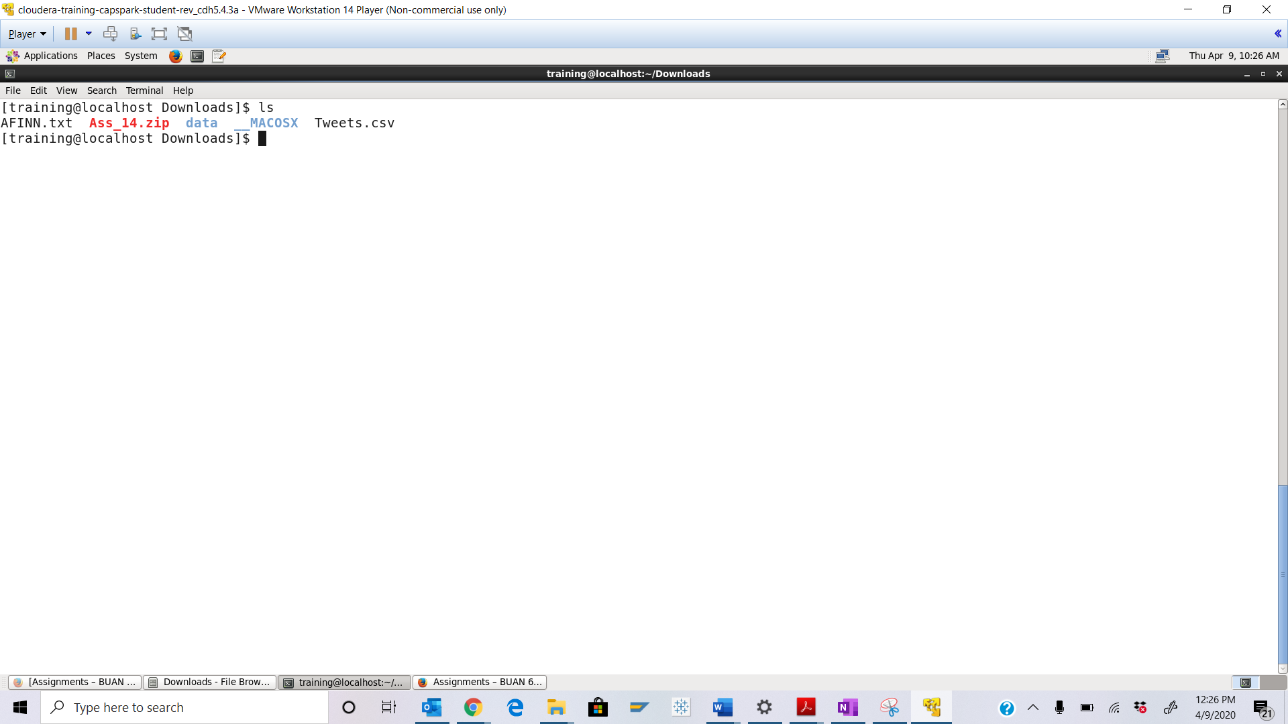



Step-5: Execute the following command at the shell prompt:



Q. Execute the command below and take a screenshot of the shell output and paste it below. Highlight the directory that we just created.



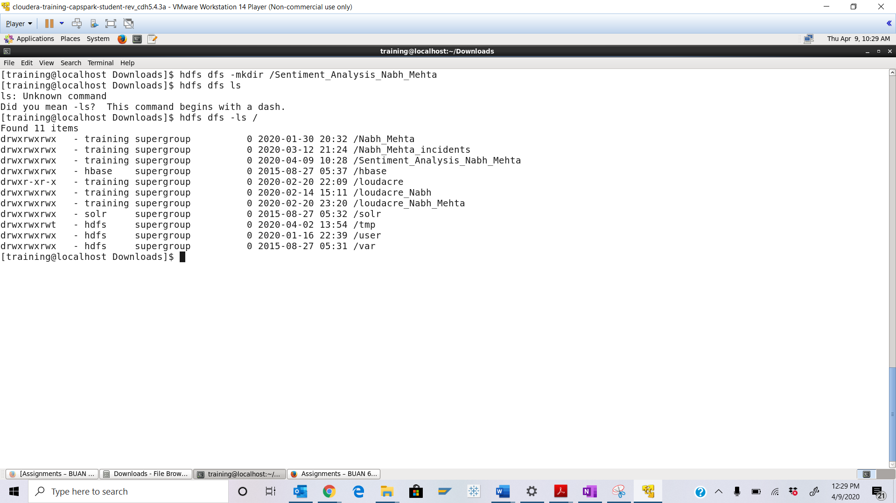



Step-6: Execute the following 2 commands at the shell prompt:



Q. Execute the command below and take a screenshot of the shell output and paste it below. Highlight the files we copied into HDFS.



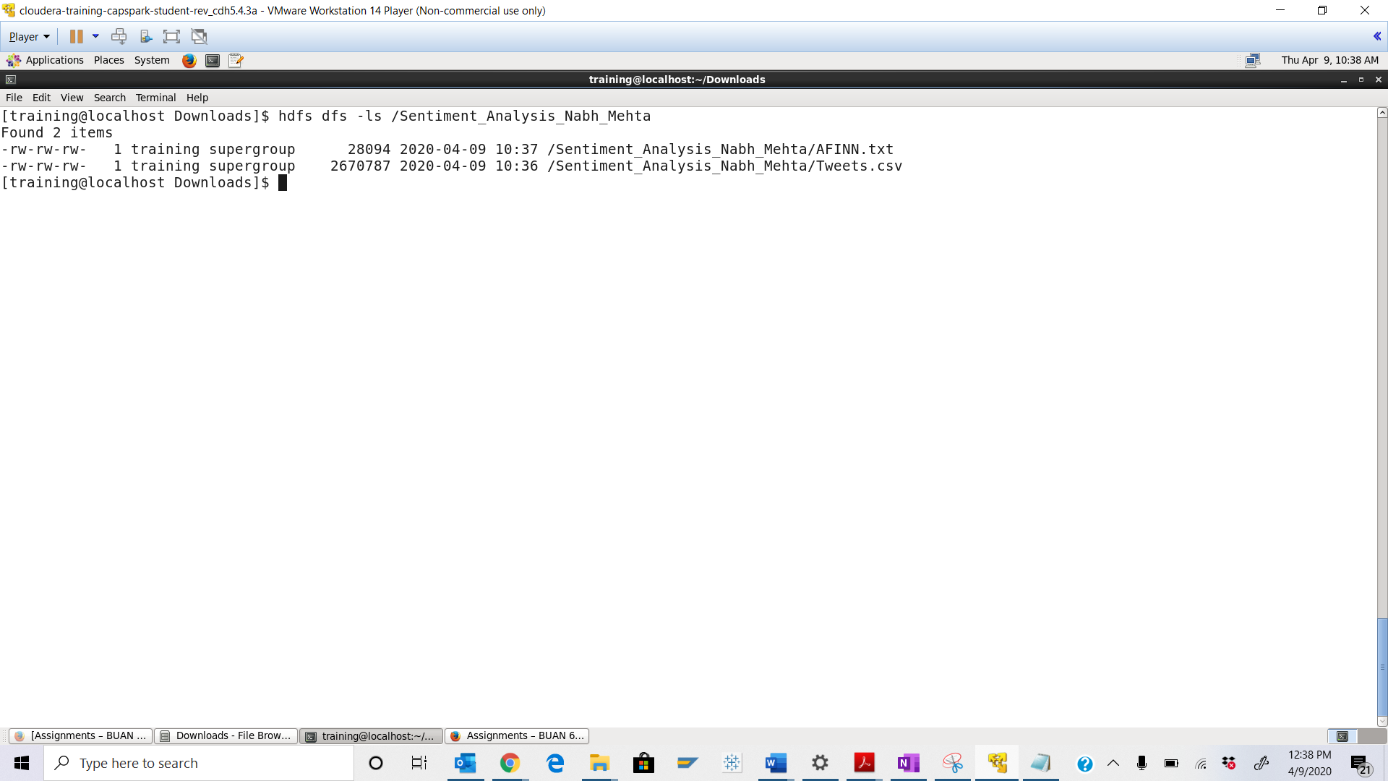

Part-2: Sentiment Analysis: In this section we will perform a sentiment analysis on tweets regarding Demonetization in India.

Step-7: Execute the following command at the shell prompt:



Q. Take a screenshot of the grunt shell output and paste it below.

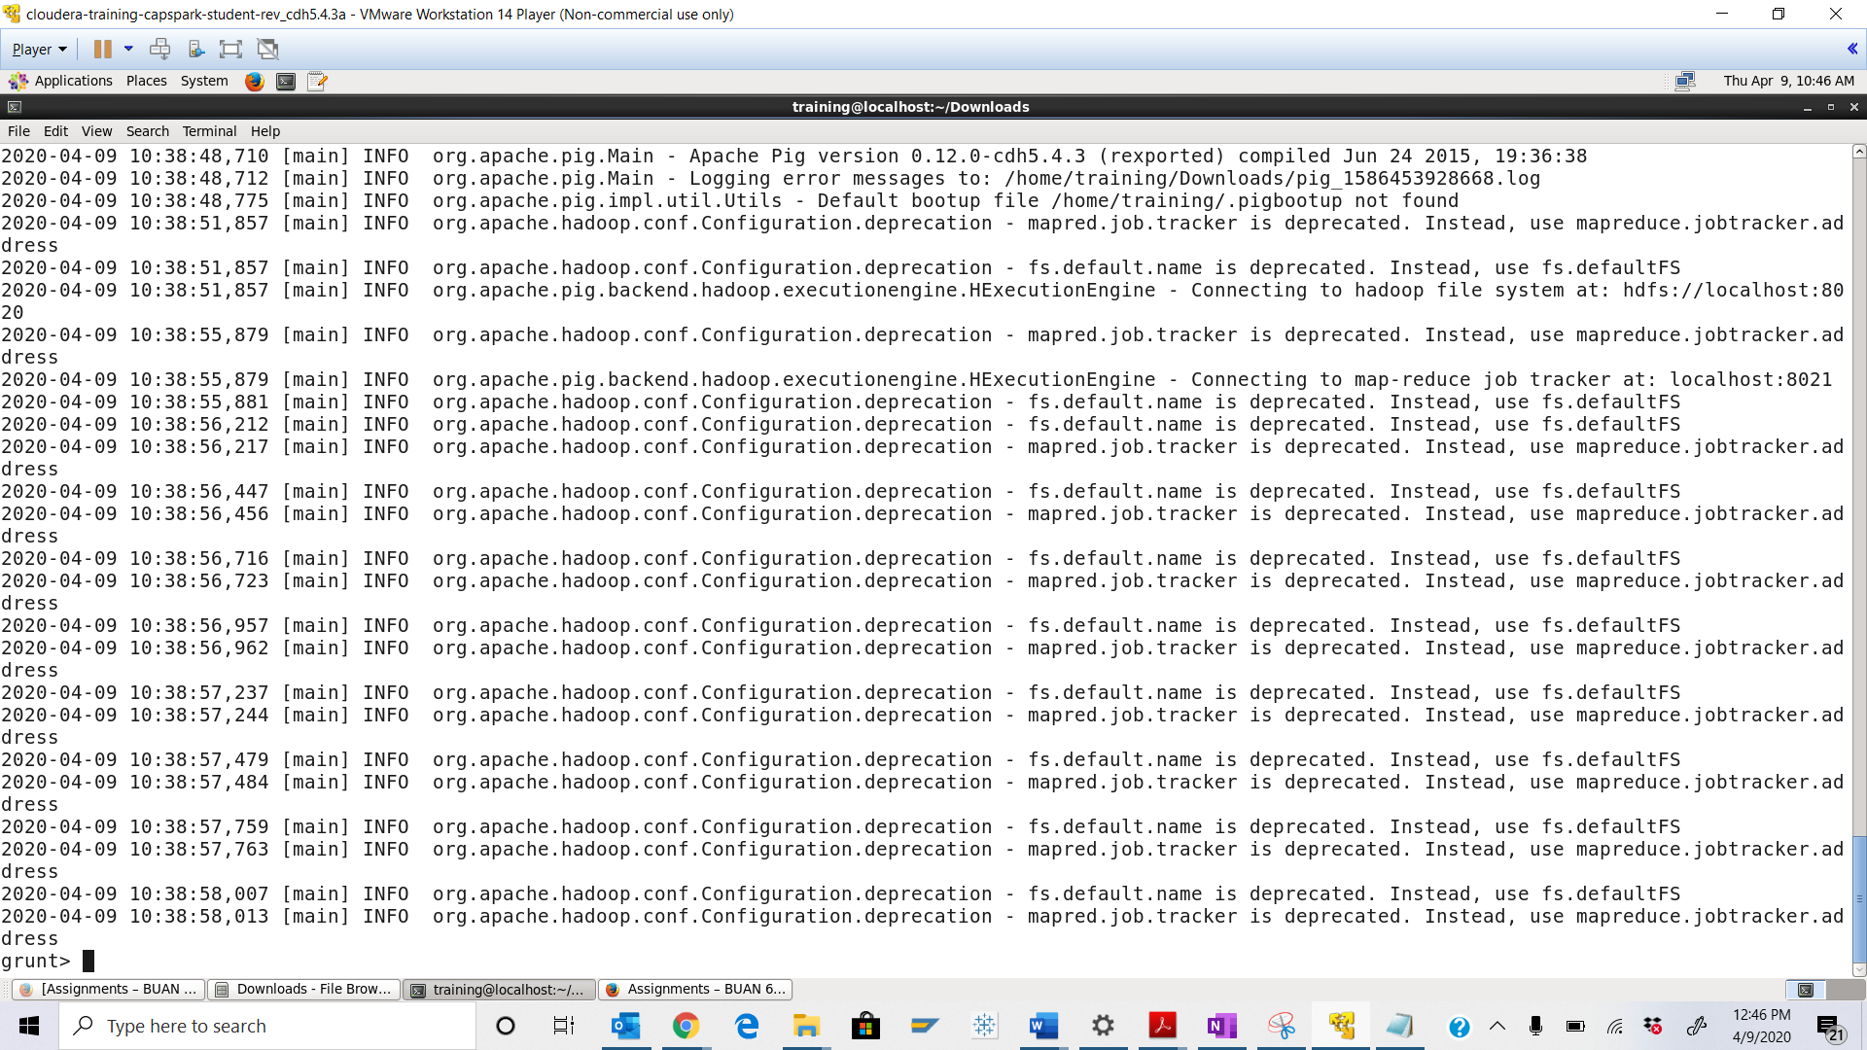

Step-8: Execute the following command at the grunt shell prompt:



Q. Execute the command below, take a screenshot of the grunt shell output and paste it below.



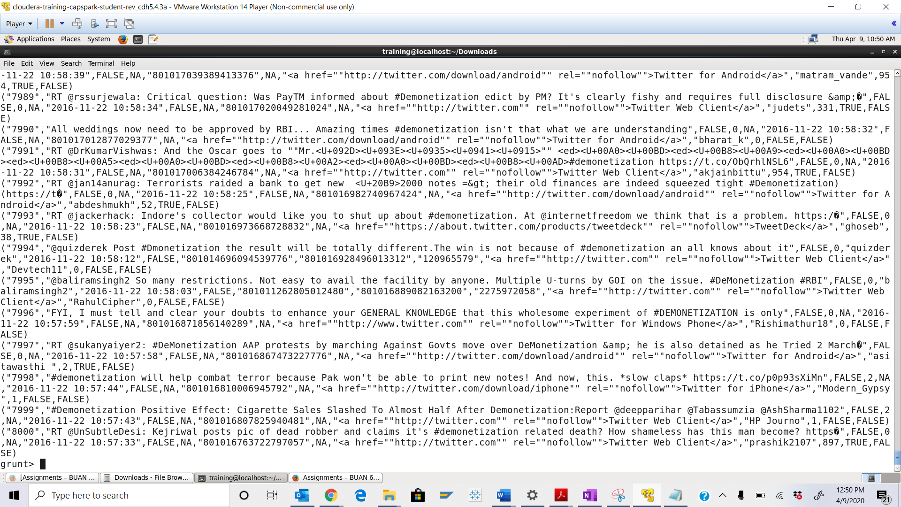

Step-9: Execute the following command at the grunt shell prompt:



Q. Execute the command below, take a screenshot of the grunt shell output and paste it below.



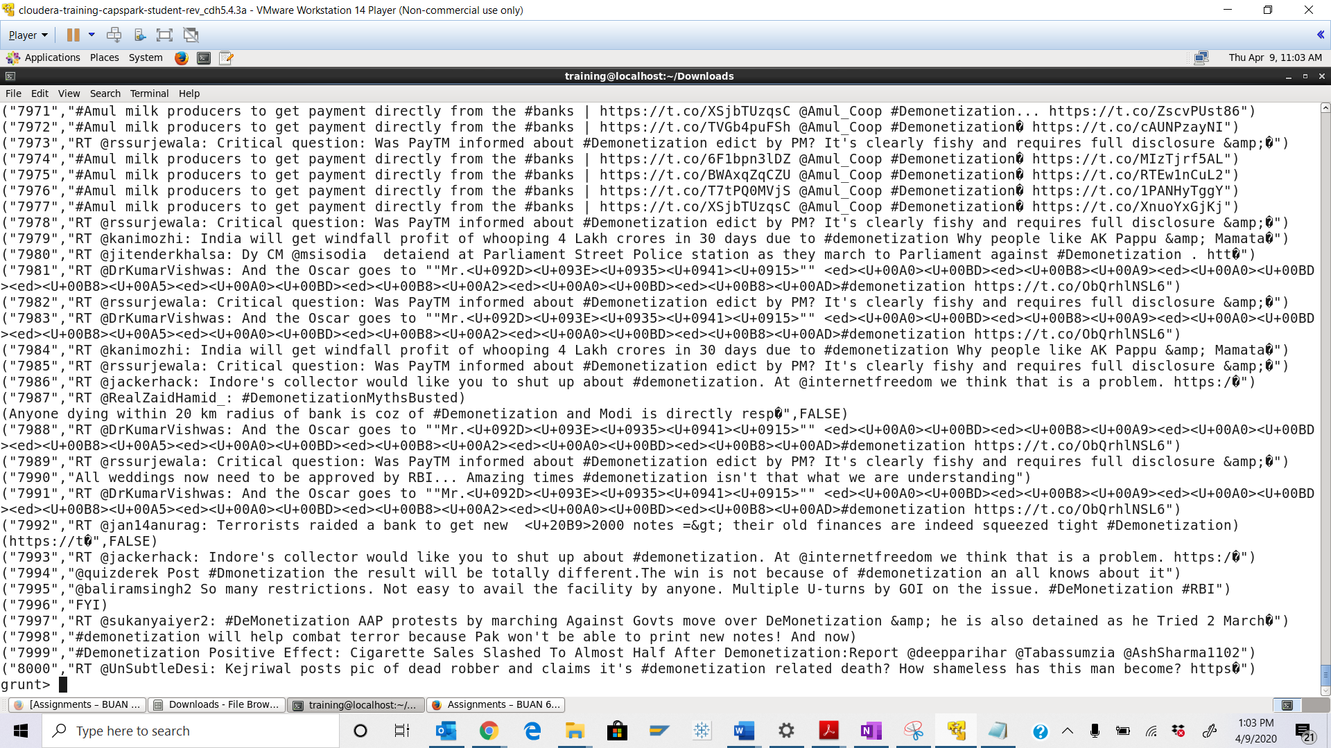

Step-10: Execute the following command at the grunt shell prompt:



Q. Execute the command below, take a screenshot of the grunt shell output and paste it below.



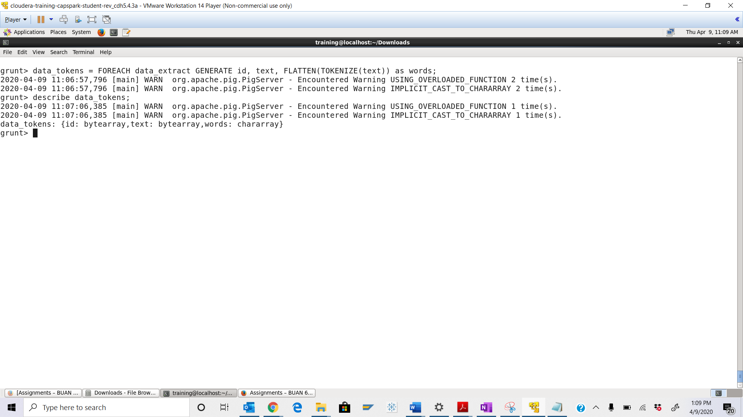

Step-11: Execute the following command at the grunt shell prompt:

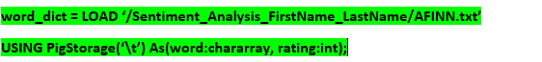

Q. Execute the command below, take a screenshot of the grunt shell output and paste it below.



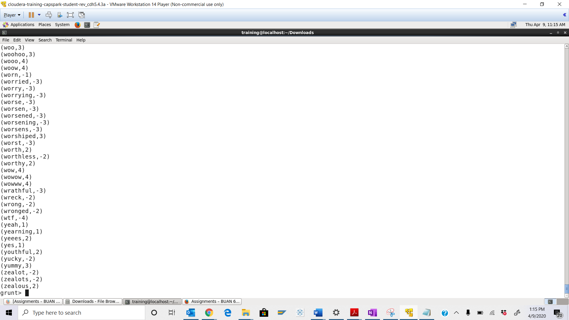

Step-12: Execute the following command at the grunt shell prompt:



Q. Execute the command below, take a screenshot of the grunt shell output and paste it below.



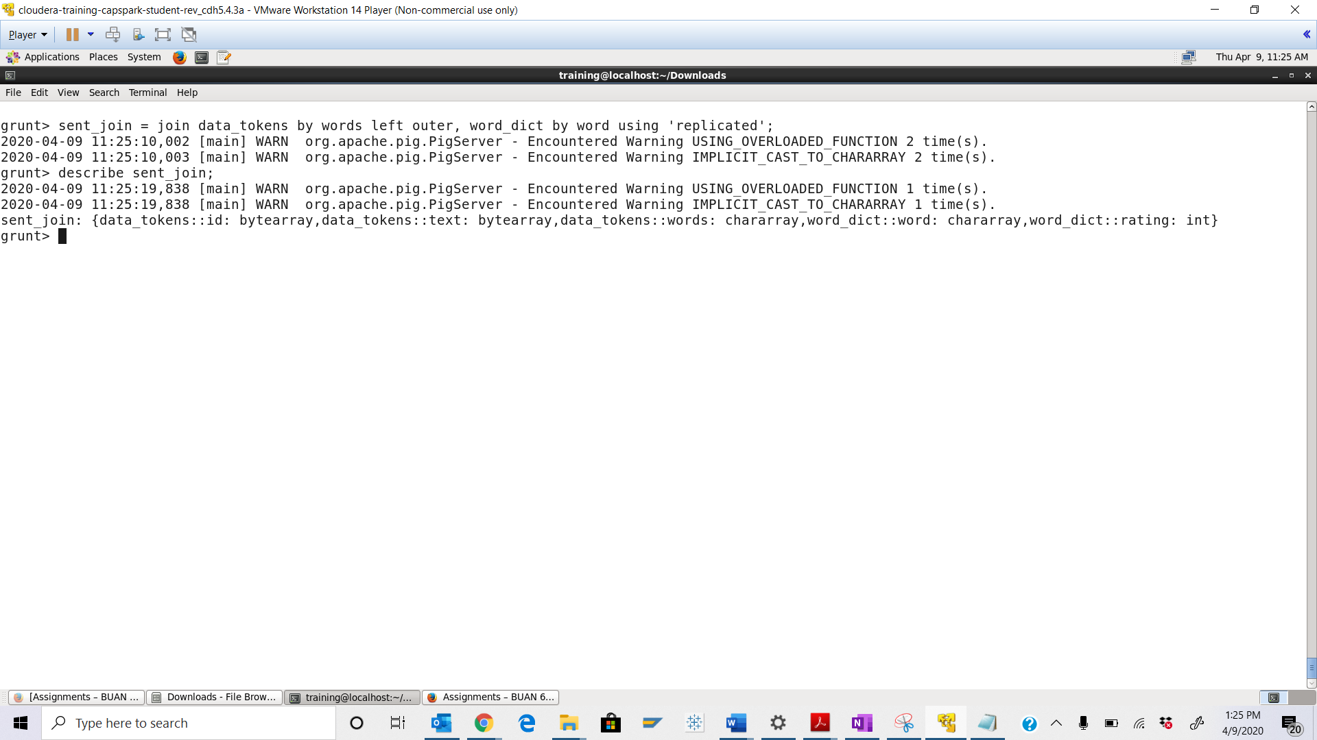

Step-13: Execute the following command at the grunt shell prompt:



Q. Execute the command below, take a screenshot of the grunt shell output and paste it below.



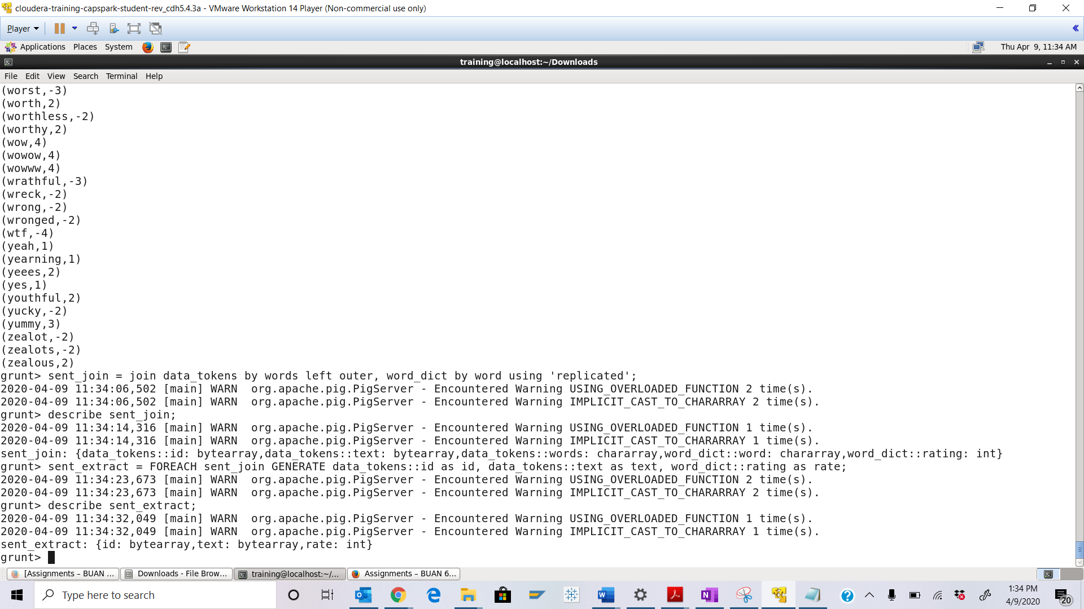

Step-14: Execute the following command at the grunt shell prompt:



Q. Execute the command below, take a screenshot of the grunt shell output and paste it below.



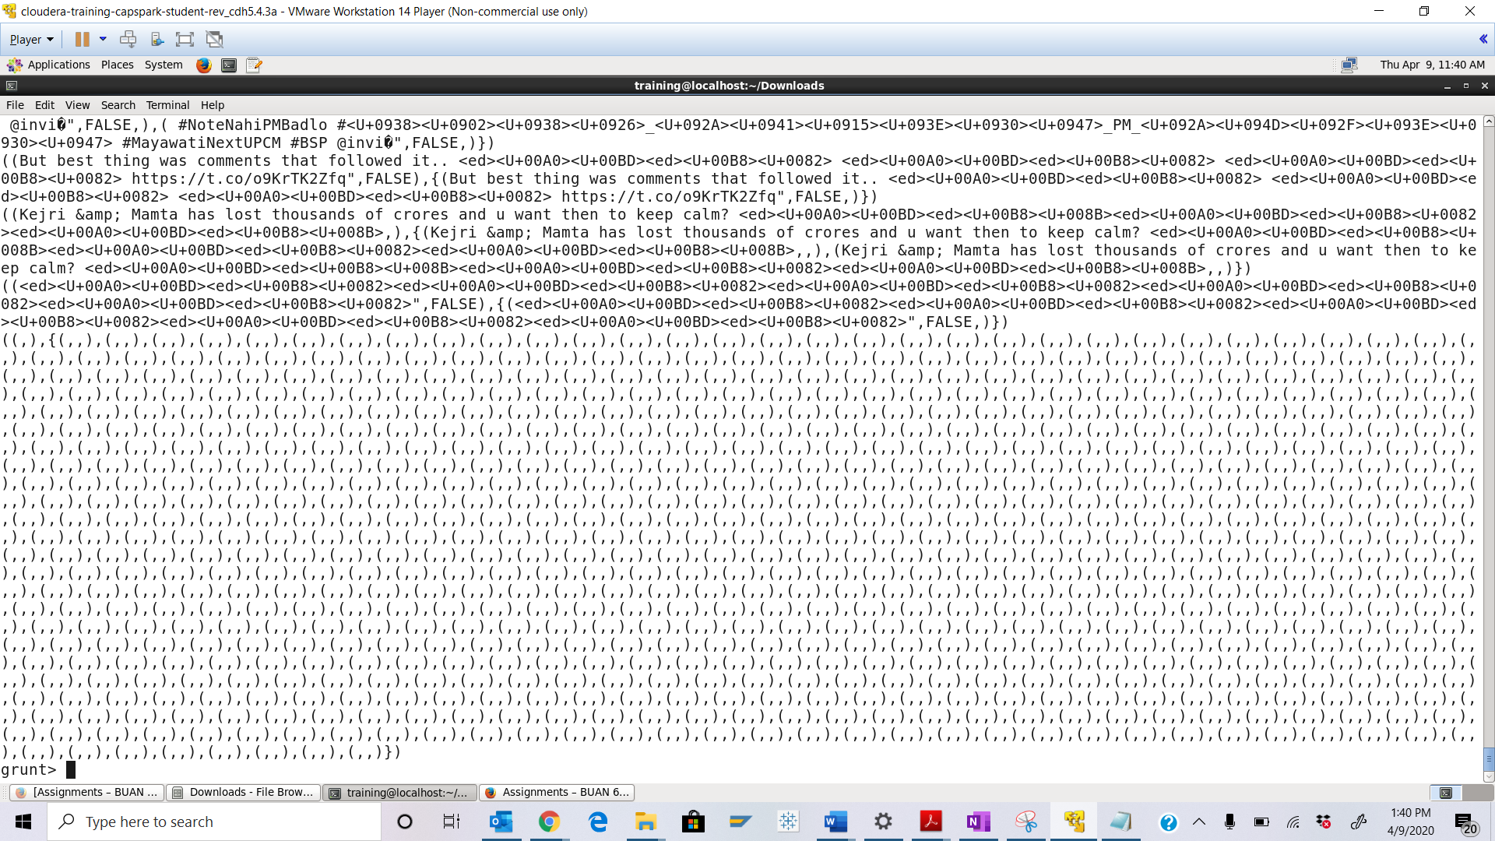

Step-15: Execute the following command at the grunt shell prompt:



Q. Execute the command below, take a screenshot of the grunt shell output and paste it below.



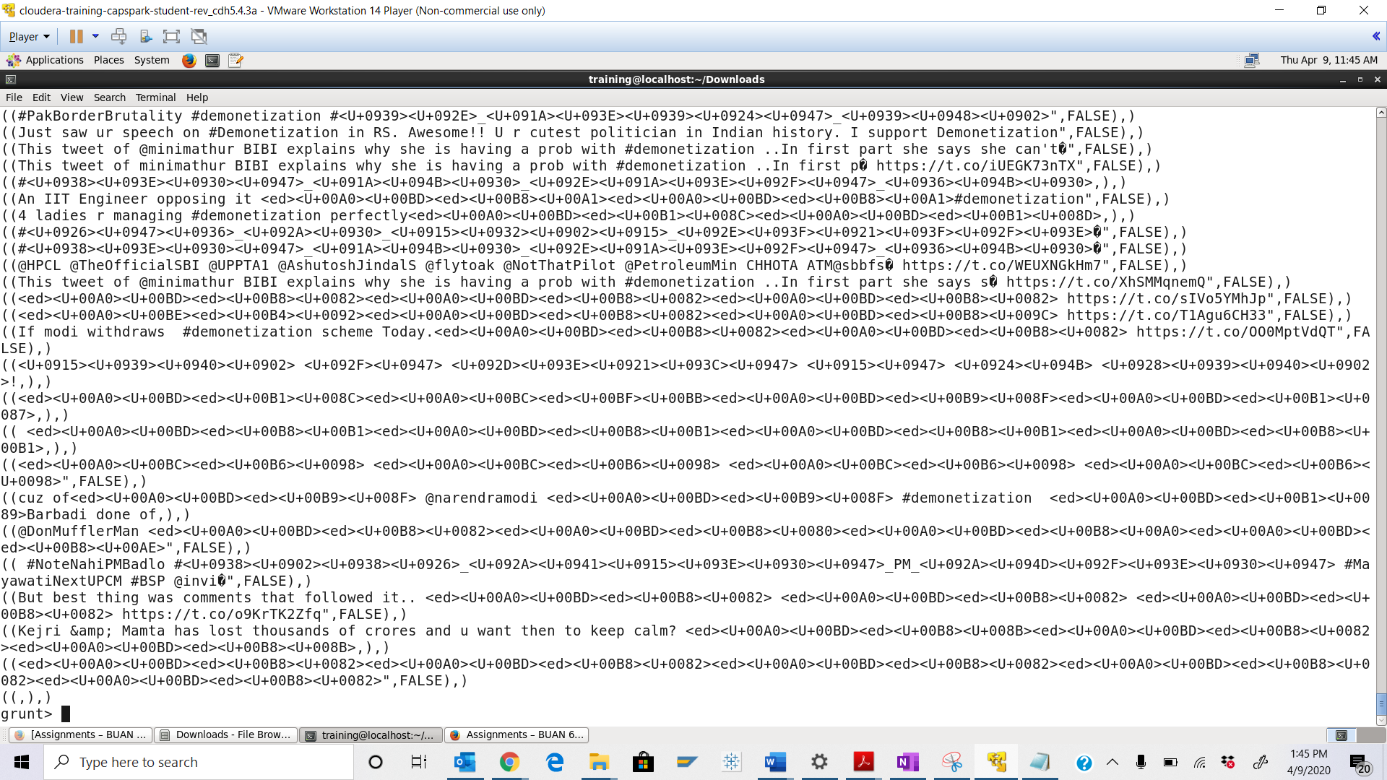

Step-16: Execute the following command at the grunt shell prompt:



Q. Execute the command below, take a screenshot of the grunt shell output and paste it below.



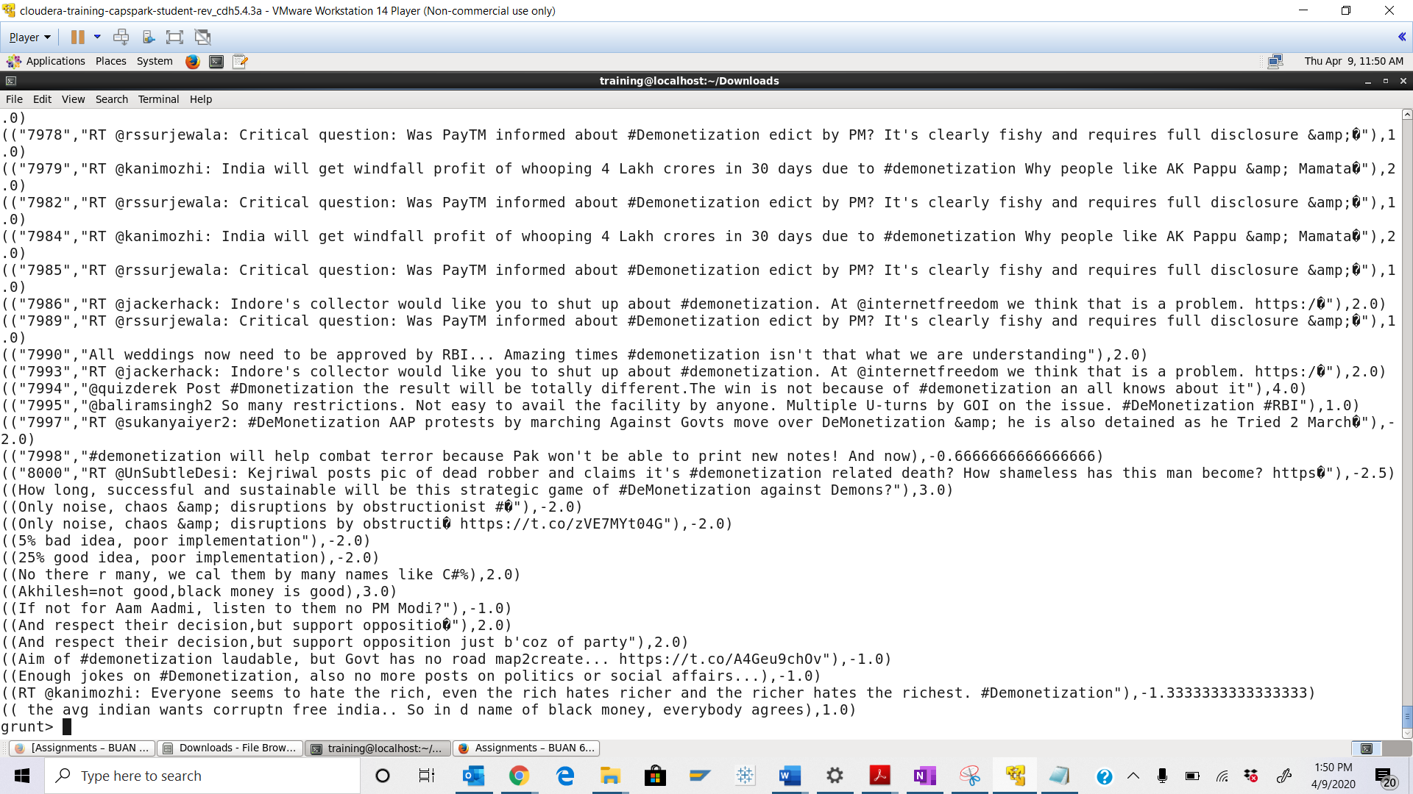

Step-17: Execute the following command at the grunt shell prompt:



Q. Open HUE and go the above directory, take a screenshot of the contents of the Analyzed_Tweets file and paste it below.

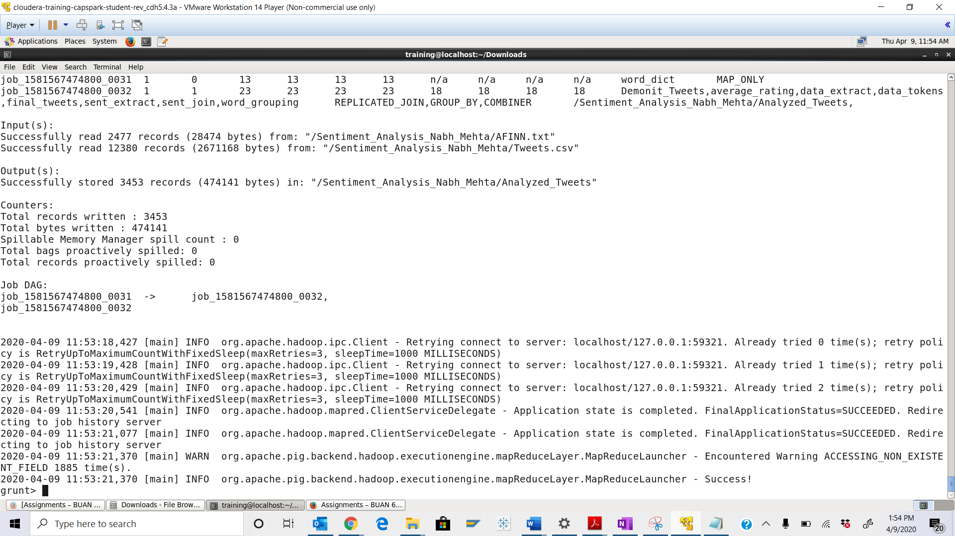

Step-18: Execute the following command at the shell prompt:



Q. Take a screenshot of the Beeline shell and paste it below.

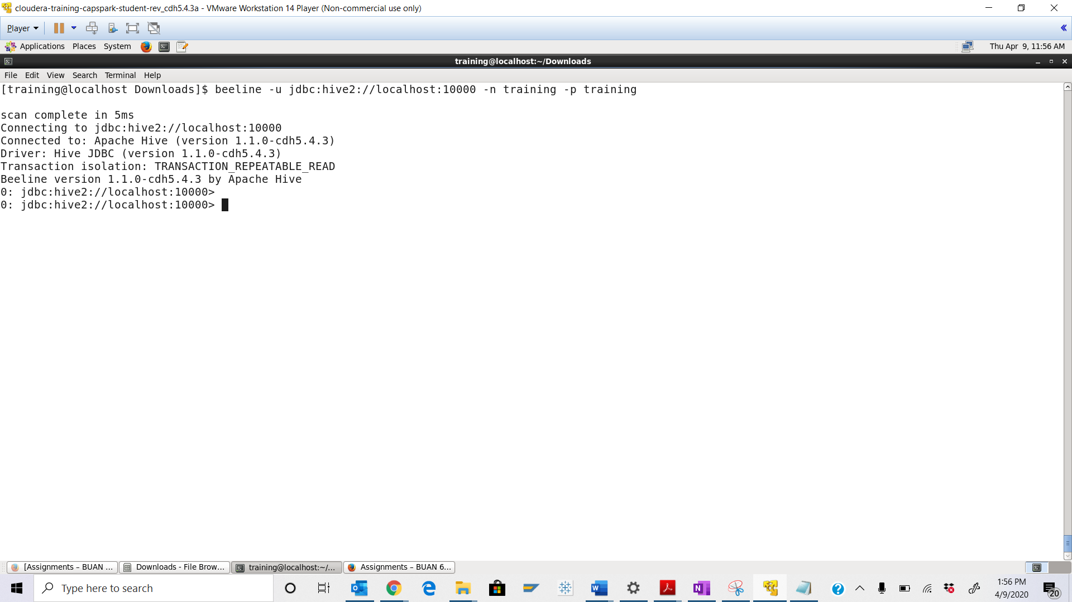

Step-19: Execute the following command at the beeline shell:



Q. Open the Hive Query Editor and click on the refresh button in the database panel, then click on the ‘Preview Sample Data’ button next to the tweety table. Take a screenshot of the sample data and paste it below.

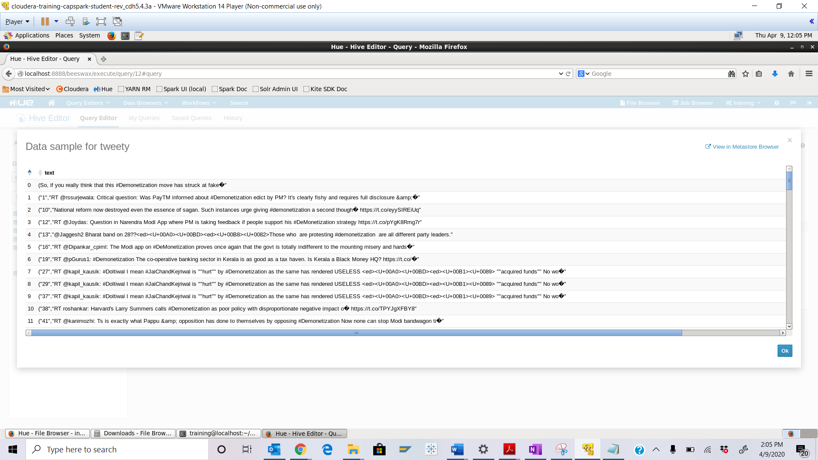

Step-20: Execute the following command at the beeline shell:



Q. Open Hue and view the file we just created, click on “View as text” on the left under ACTIONS. Take a screenshot of the contents and paste it below.

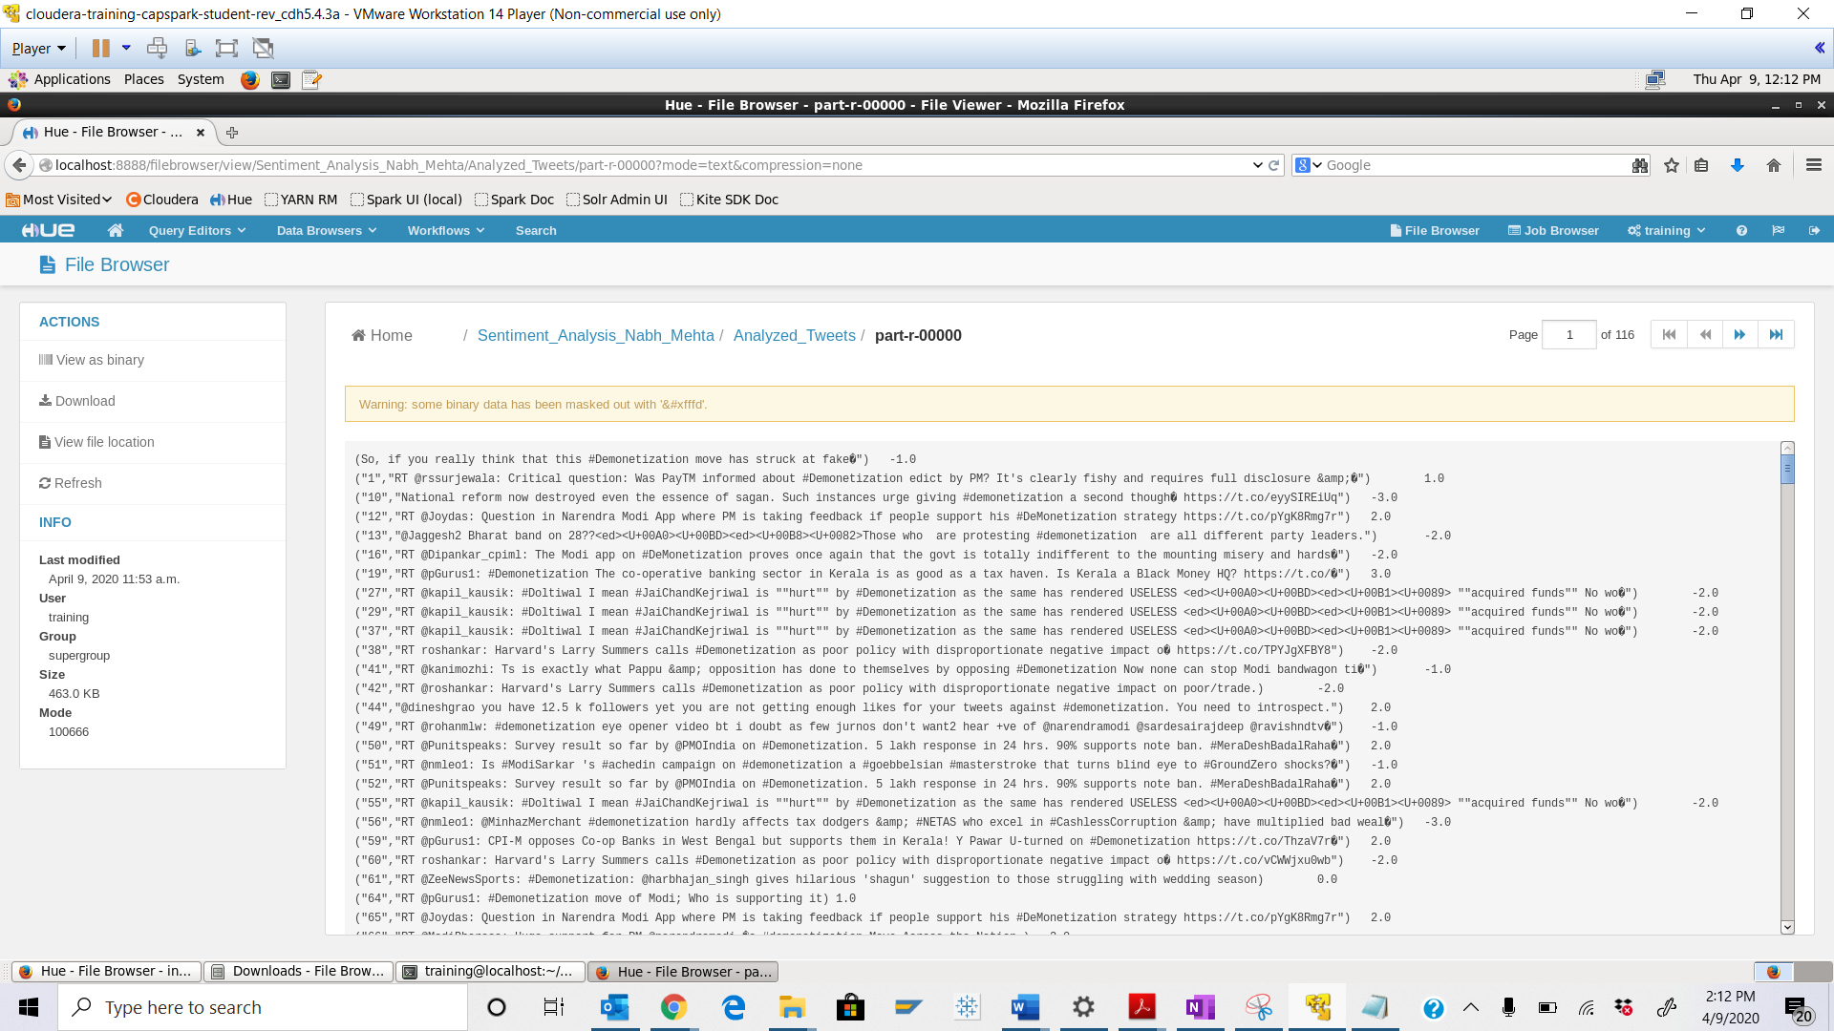

Part-3: Visualization of Sentiments: In this section we will visualize the results of our sentiment analysis using Jupyter notebooks.

Step-21: Exit Beeline then execute the following command at the shell prompt:





Q. Execute the 2 commands below and take a screenshot of the shell output and paste it below. Highlight the file we copied from HDFS.



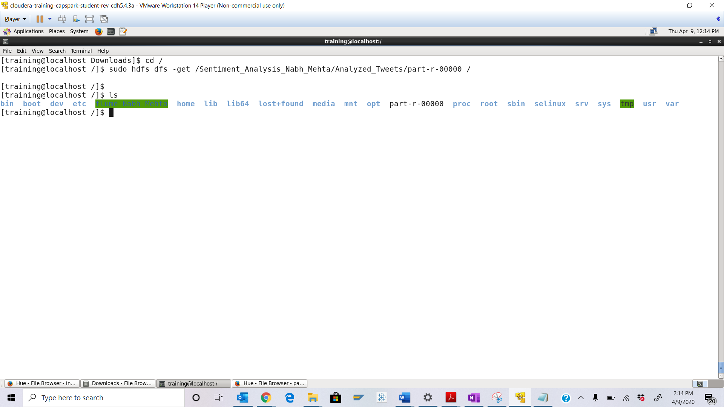



Highlighted in Yellow

Step-22: Using Firefox, browse to the following address:

<https://jupyter.org/try>

Q. Take a screenshot of the Jupyter Splash screen and paste it below.

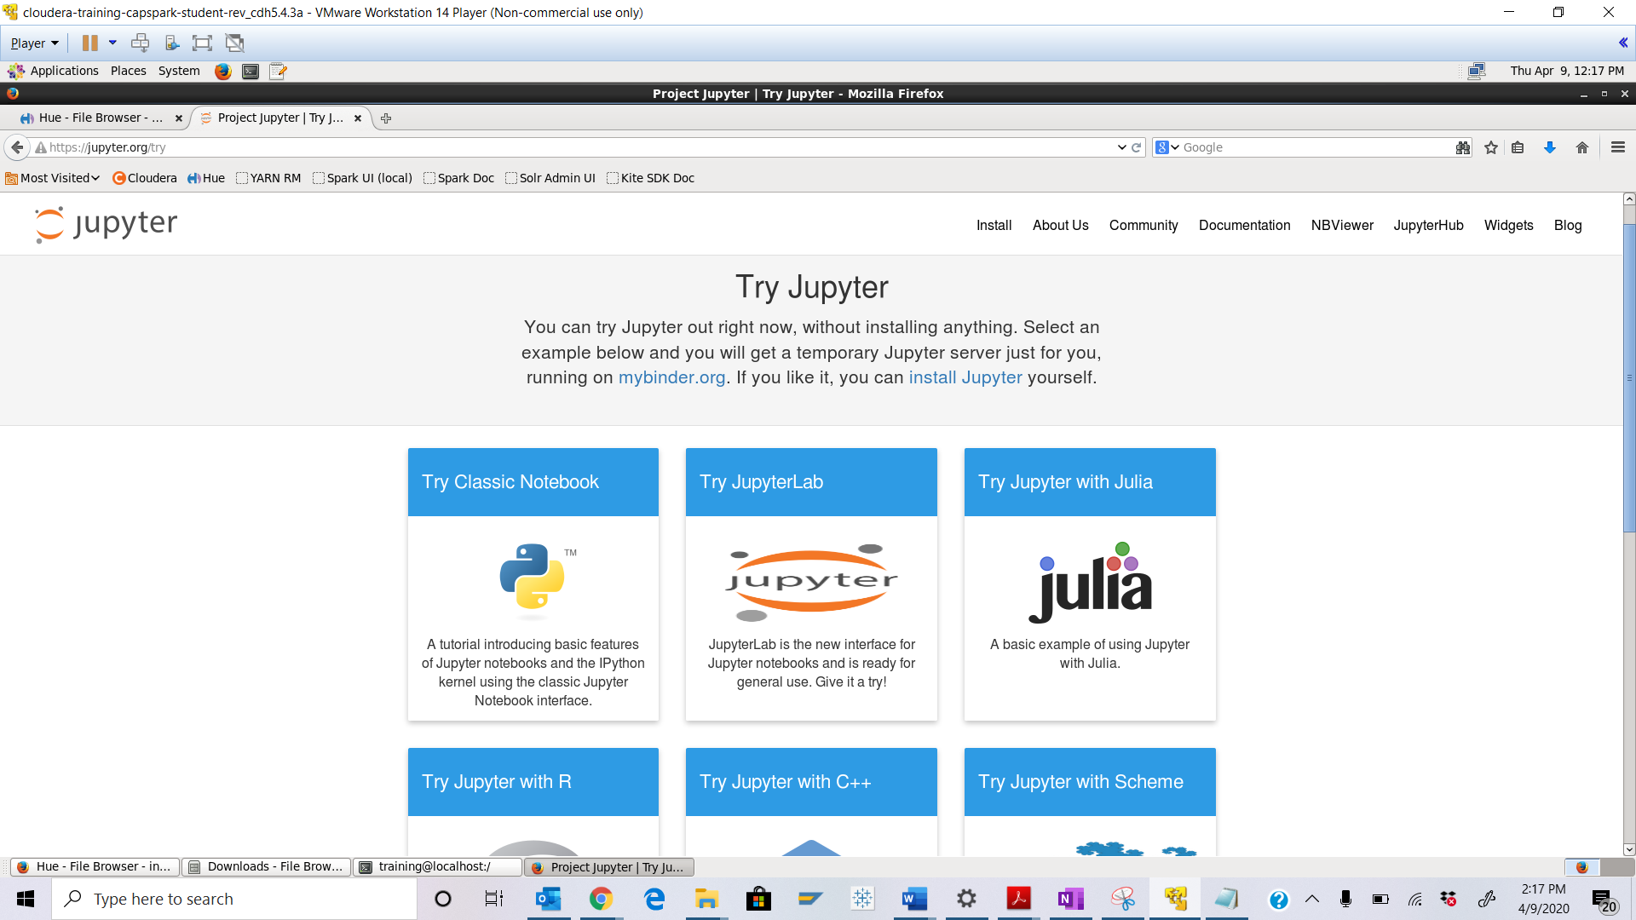

Step-23: On the Jupyter homepage click on the “Try Jupyter with Python” icon that is highlighted in the screenshot below:

Q. Wait for a minute for the page to load then take a screenshot of the page you land on and paste it below.

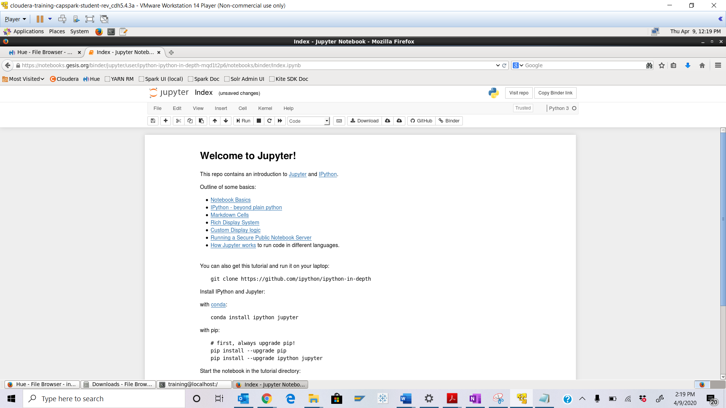 Step-24: Now click on the homepage button highlighted in the screenshot below.

Q. Wait for a minute for the page to load then take a screenshot of the page you land on and paste it below.

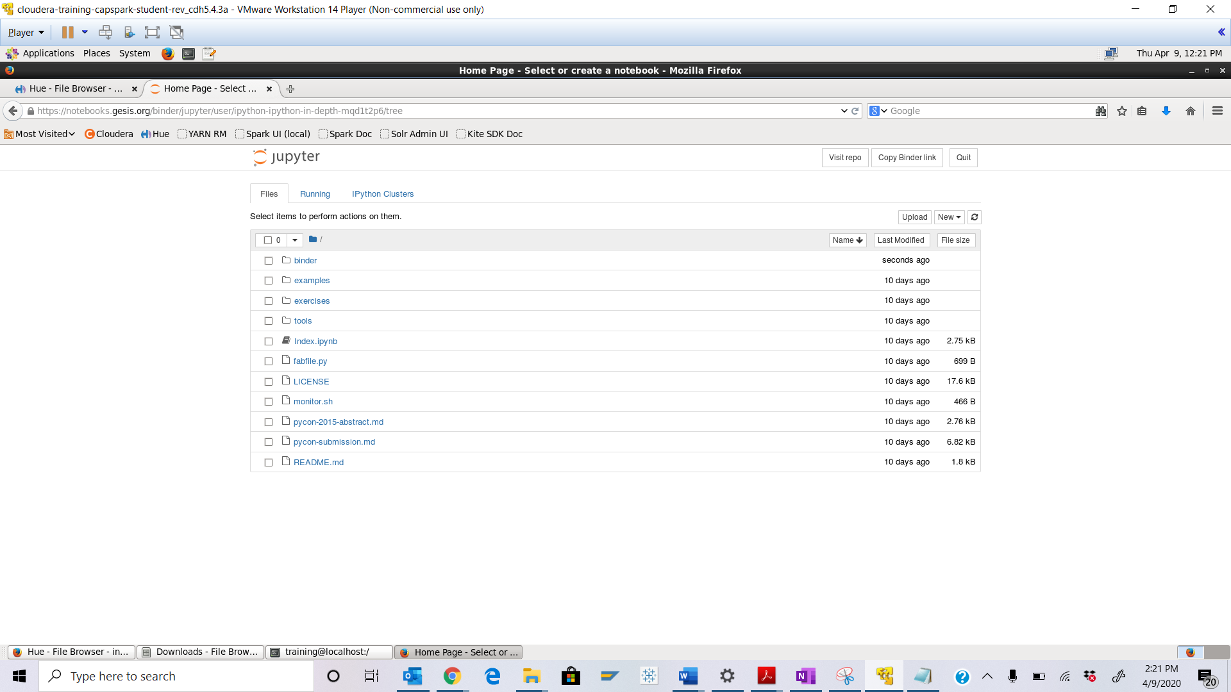

Step-25: Now click on the “Text File” button highlighted in the screenshot below.

Q. Take a screenshot of the page you land on and paste it below.

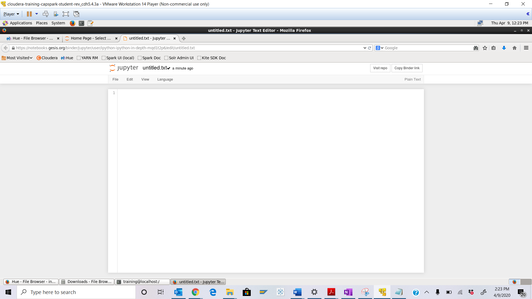 Step-26: Now open the file containing the calculated sentiments in the computer application. After opening the computer application click on the filesystem folder highlighted in the screenshot below.

Open the part-r-00000 and copy the contents and paste it in the browser running Jupyter we opened in Step-25. Save the file as “part-r-00000”. Force save the file.

Q. Click on the Jupyter icon like in Step 24 and highlight the new file you just created.

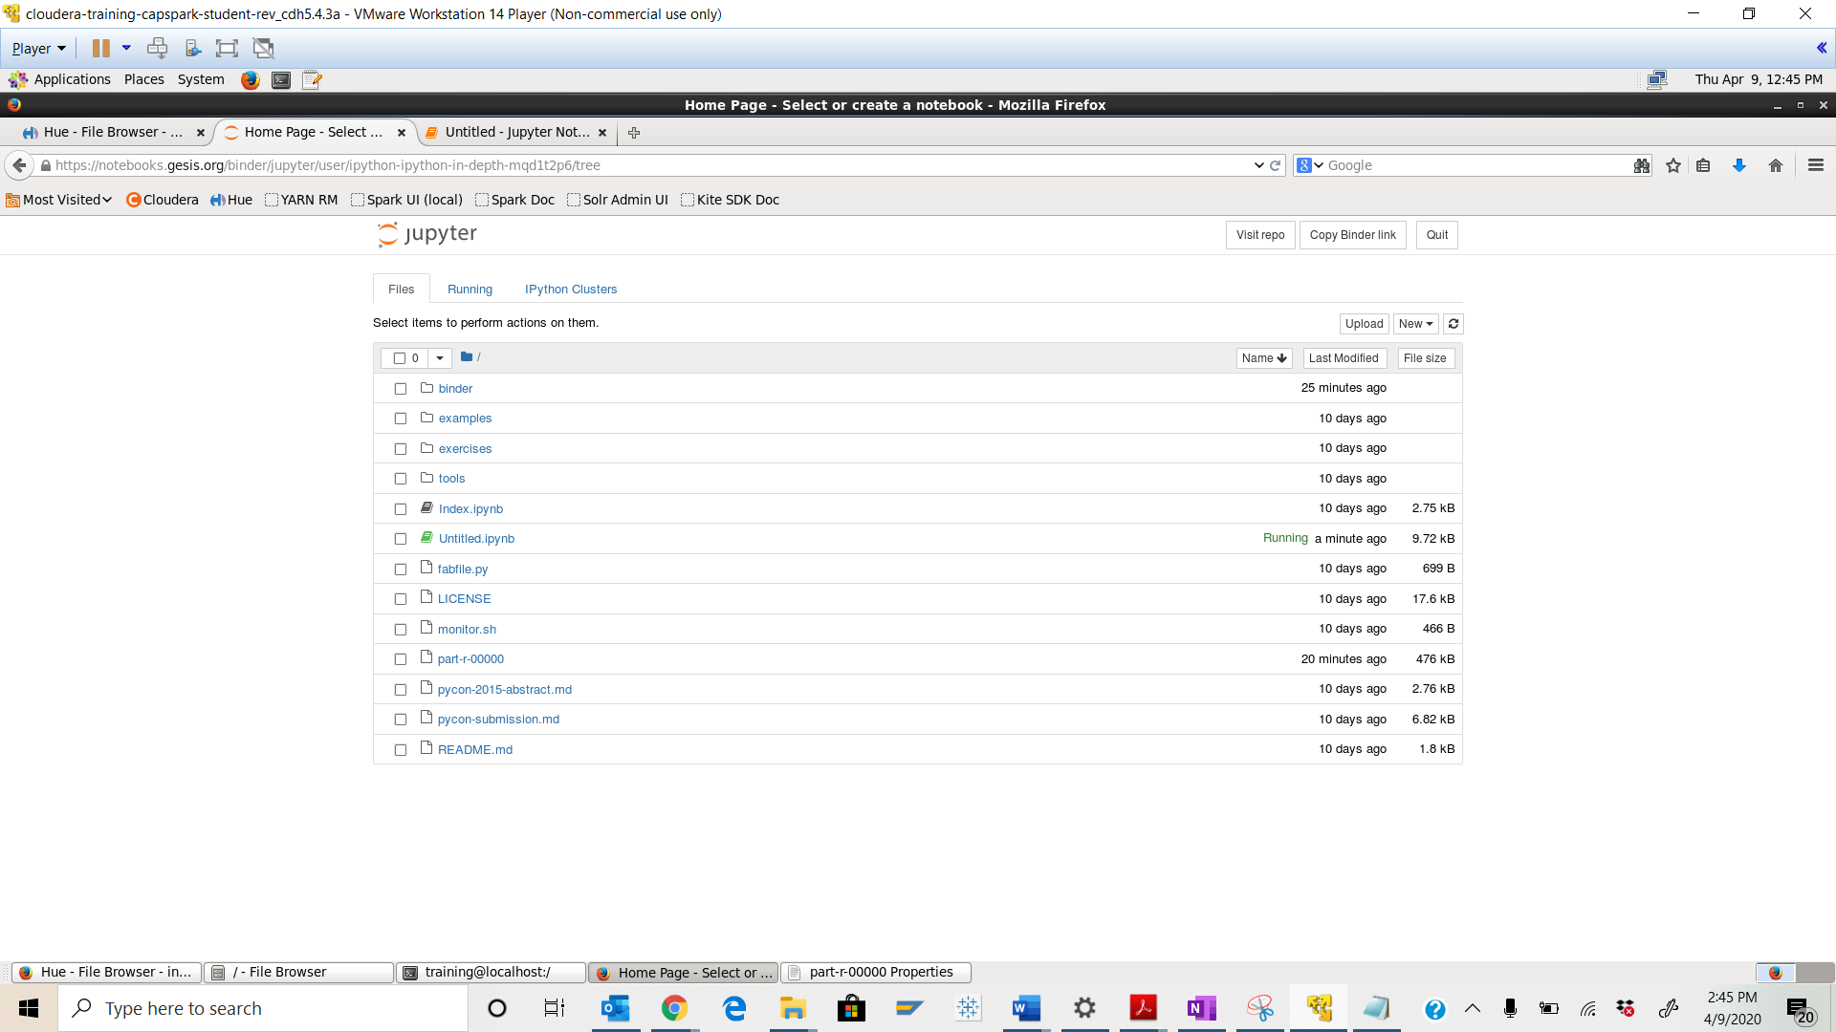



Step-27: Now create a Python 3 Jupyter Notebook file by clicking on the “Python 3” button highlighted in the screenshot below

Q. Take a screenshot of the page you land on and paste it below.

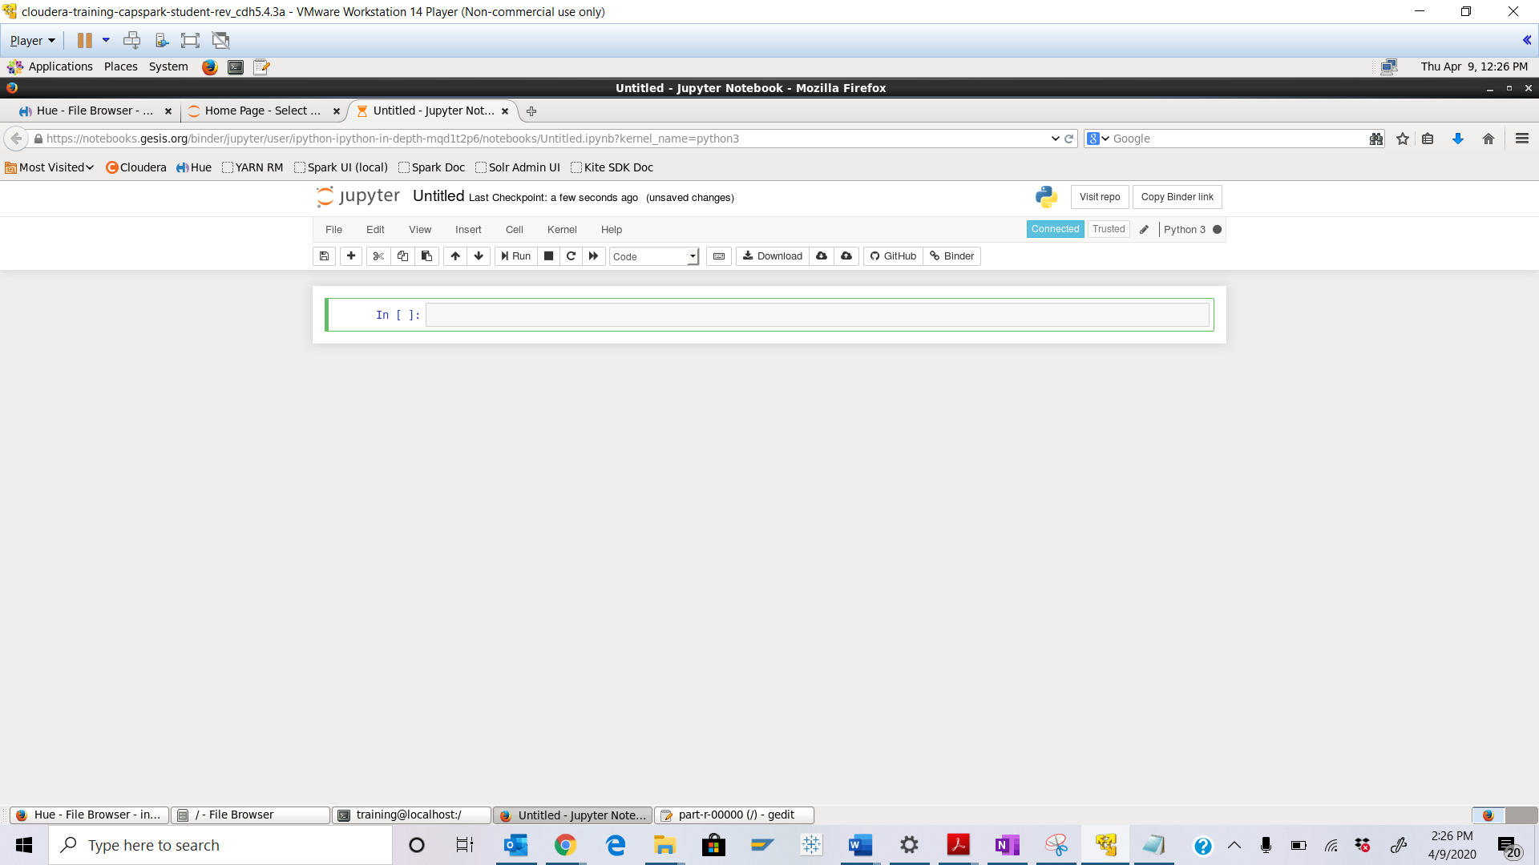

Step-28: Now type the code in the screenshot below at the prompt (after In [ ]:) then hit Run.

. Take a screenshot of the output and paste it below. Provide your inferences from the graph generated in this step.

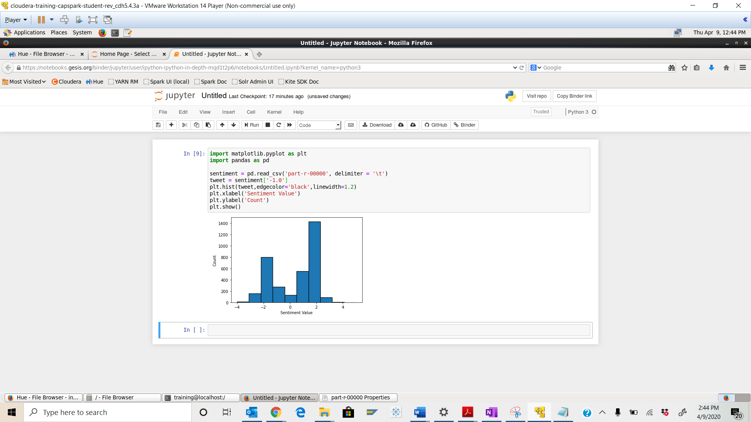 Part-4: Checksum: In this section we will perform a checksum

Step-29: Download the Checksum.zip file from eLearning in to the downloads folder **IN** the Cloudera VM using Mozilla Firefox.

Step-30: Execute the following command:



Q. Now type the command and execute. Take a screenshot of the shell output, highlight the zip file and paste it below.

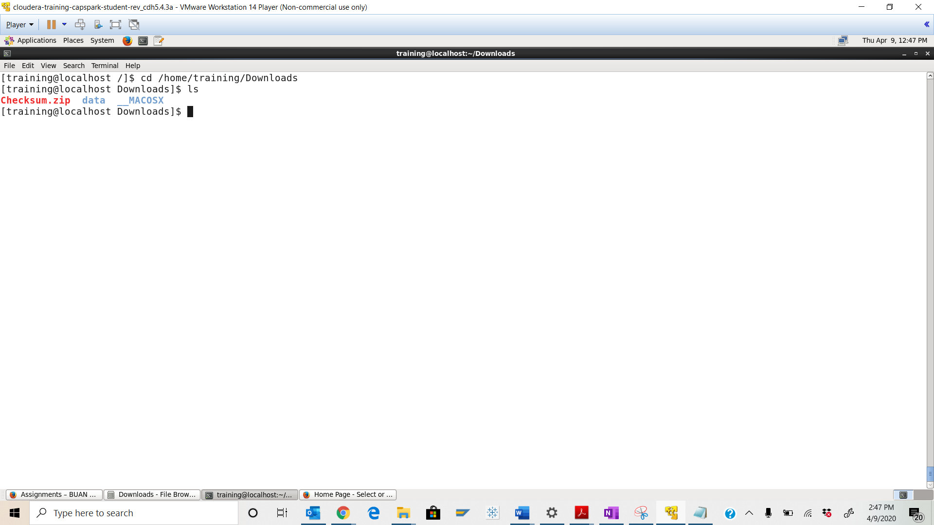



Step-31: Execute the following command at the shell prompt:



Q. Now type the command and execute. Take a screenshot of the shell output, highlight the contents of the zip file and paste it below.

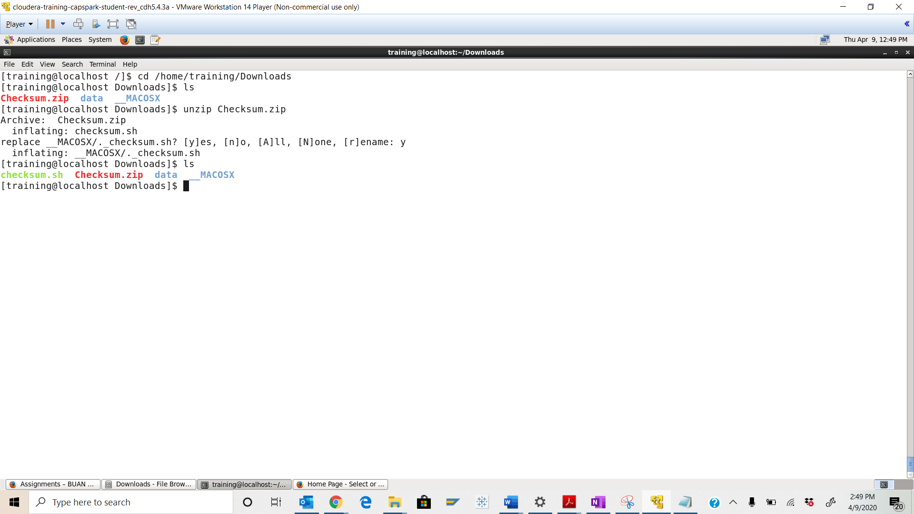



Step-32: Execute the following command at the shell prompt:

Then execute the following command:

Q. Take a screenshot of the shell output and paste it below.

checksum value - 9b2eb471695184e8b2d65495eec068cc

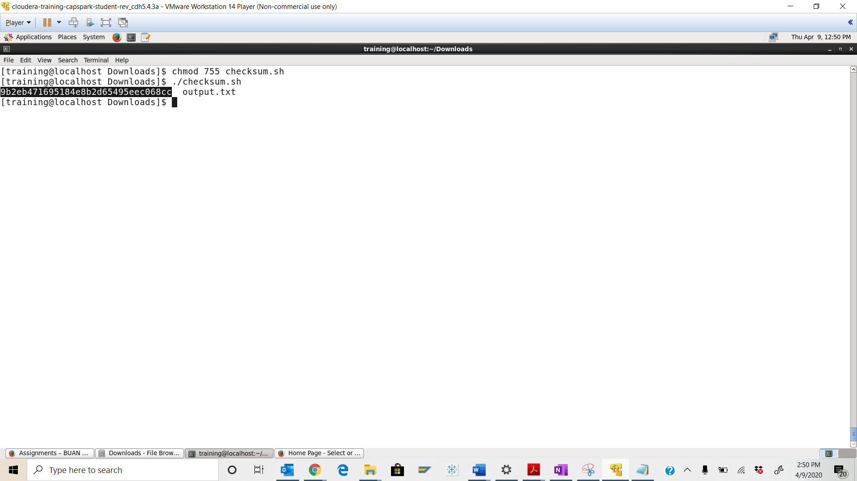

Step-33: Execute the following command at the shell prompt:

rm Checksum.zip checksum.sh output.txt



Q. Now type the command and execute. Take a screenshot of the shell output and paste it below.

